



USER

GUIDE

USER GUIDE

Mentoring, Referral & Grievance

N EW D E L H I

S EP T EM B ER 2 0 2 2

Table of Contents

1. Registration 3

1.1 Add use of Cash 3

1.2 Add Mentoring 4

1.3 Add Referral 6

1.4 Add Grievance 7

## Registration

Login as **Peer Mentor** to add mentoring, referral and grievance of the participants you have been assigned for. After successful login, navigate to the **Registration** module which allow you to perform the following actions on the participants –

* Add use of Cash
* Add Mentoring
* Add Referral
* Add Grievance

Below is the brief description about each in detail.

### 1.1 Add use of Cash

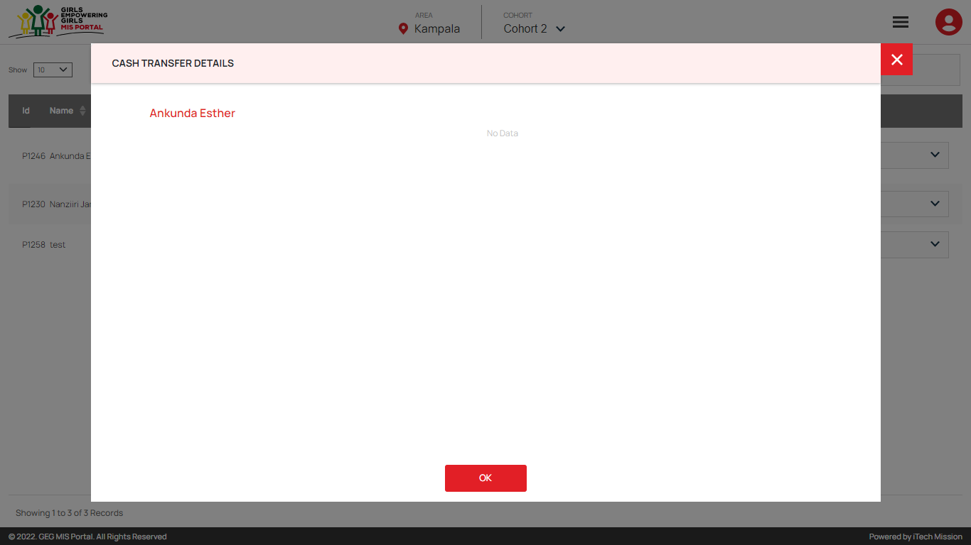Click on the **Select** dropdown available under action column and select **Cash Transfer** option from the available menu options. A pop window will appear which will show the cash transfer details of the selected participants if any (see below figure).

Click on the **Edit** button to add the use of cash of each participant.

### 1.2 Add Mentoring

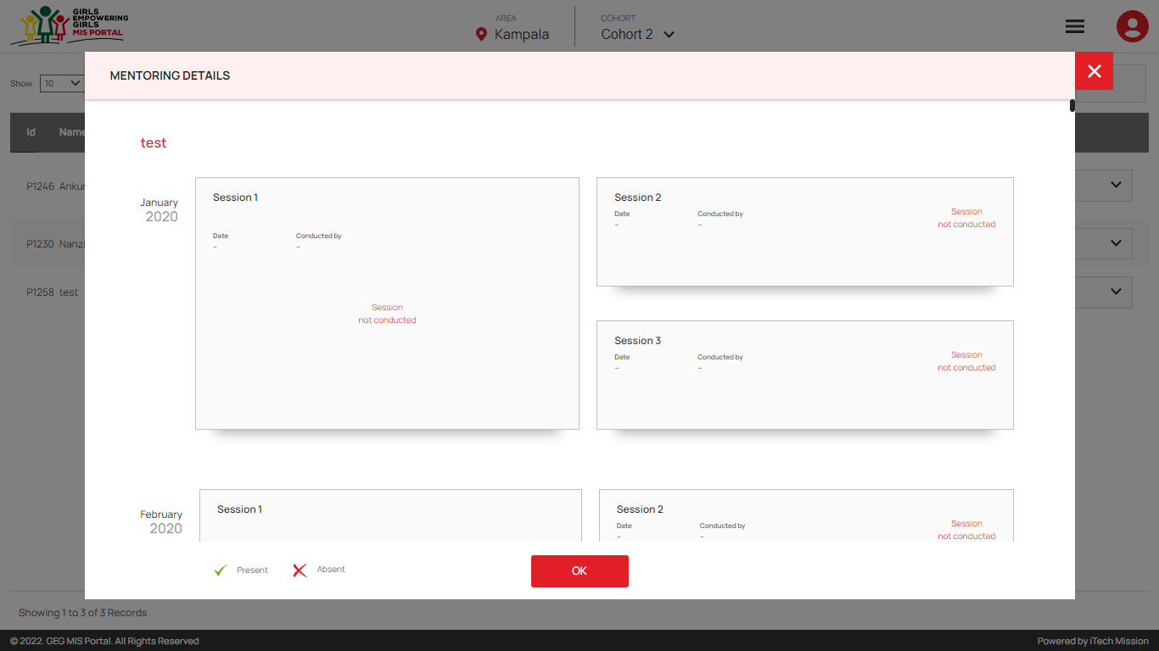Click on the **Select** dropdown available under action column and select **Mentoring** option from the available menu options. A pop window will appear which will allow you to add one group session and two one-on-one sessions conducted in each month with all the participants (see below figure).

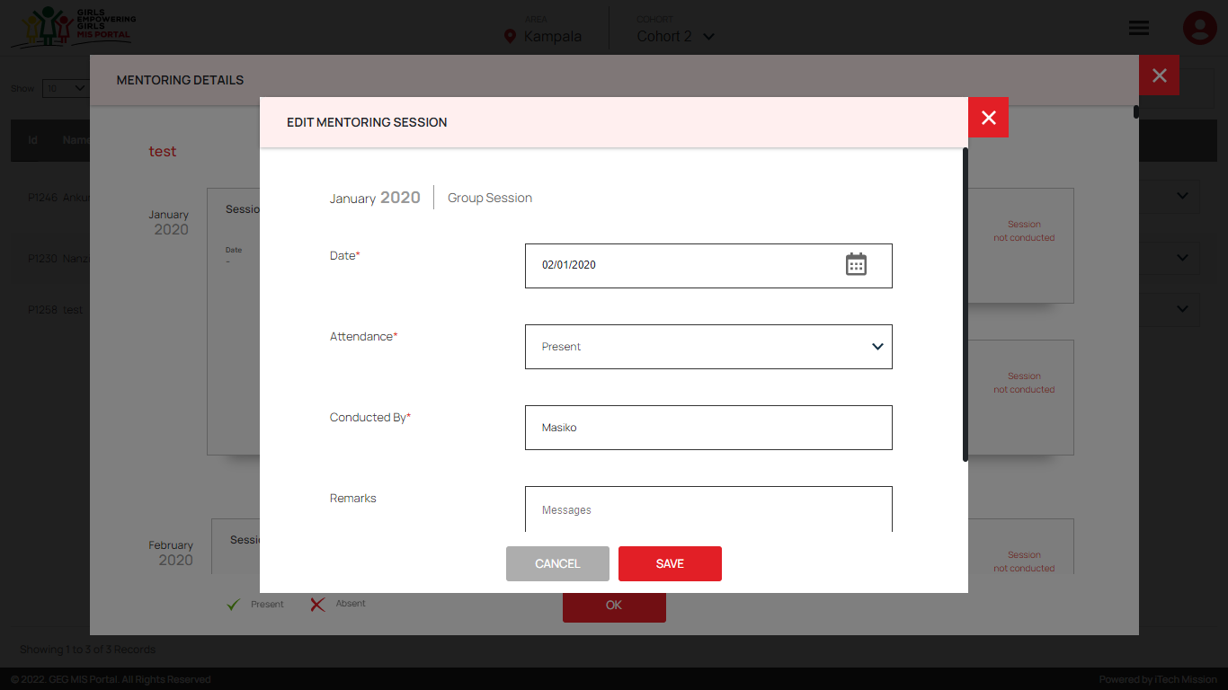****Click on the **Edit** button to add the details of the group session of the selected participant and save (see below figure).

A **tick** mark will appear in case the selected participant was present in the 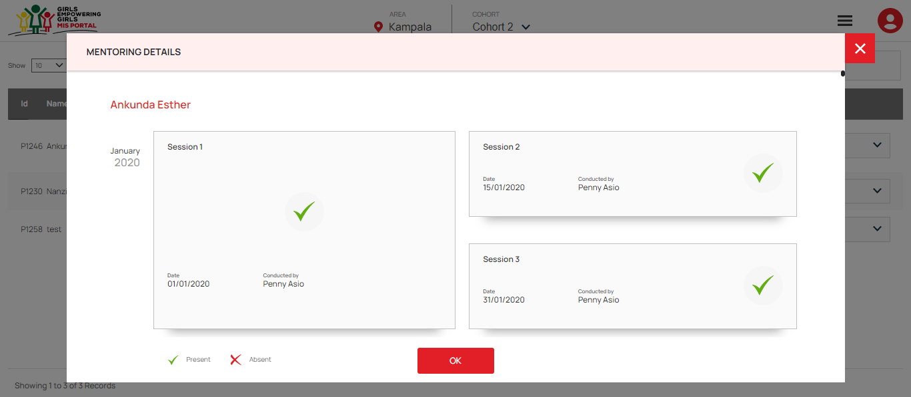session else a cross will appear (see below figure).

After the session has been added, click on the **View** button to view the details of the group session.

****Click on the **Delete** button to remove the added details of the session. Add the one-on-one sessions conducted in the same manner as added for group sessions.

|  |
| --- |
| *“First two weeks and Last two weeks school attendance is required to be added only in case of In-School girl while adding the mentoring details.”* |

### 1.3 Add Referral

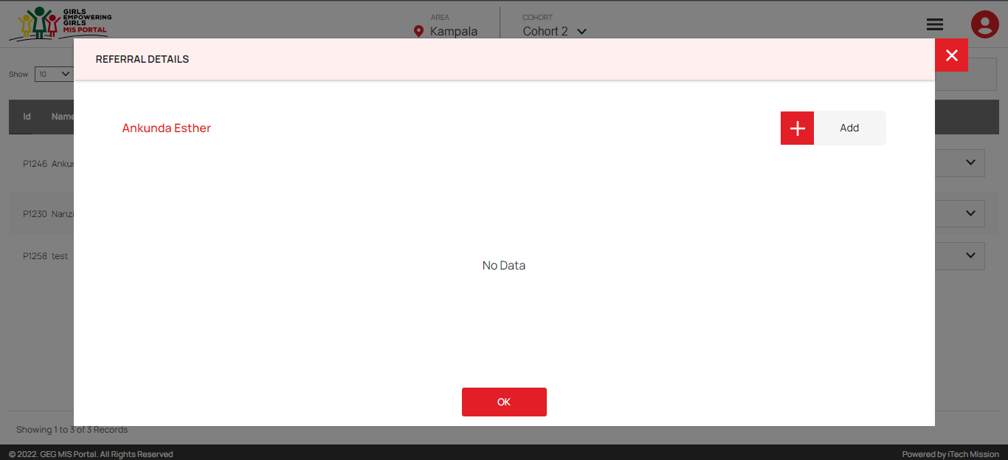Click on the **Select** dropdown available under action column and select **Referral** option from the available menu options. A pop window will appear with the option to add the referrals of the selected participant (see below figure).

Click on the **Add** button and fill the following details in order to add the referral -

* Reporting Date
* Type of Referral
* Referred by
* 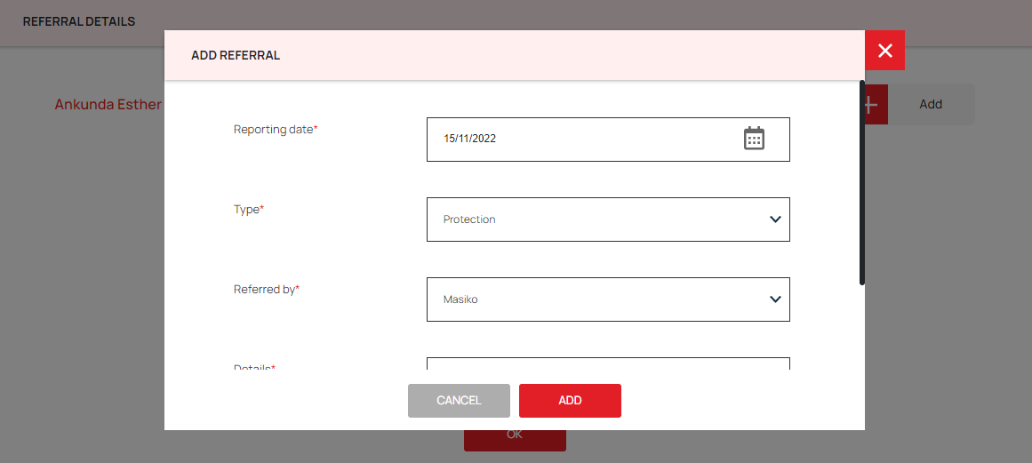Details

### 1.4 Add Grievance

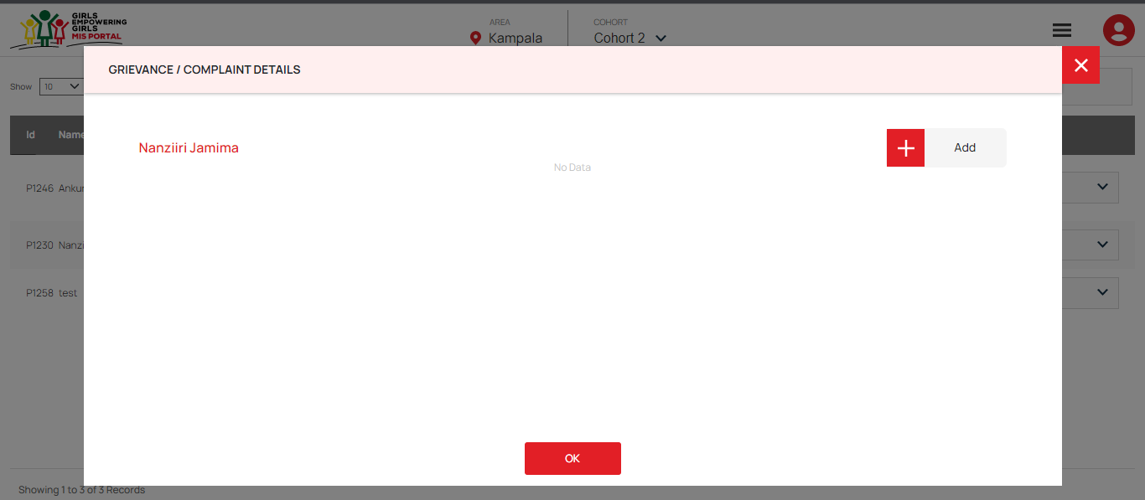Click on the **Select** dropdown available under action column and select **Grievance** option from the available menu options. A pop window will appear with the option to add the grievance of the selected participant (see below figure).

Click on the **Add** button and fill the following details in order to add the referral -

* Reporting Date
* Case Category
* Channel Used
* 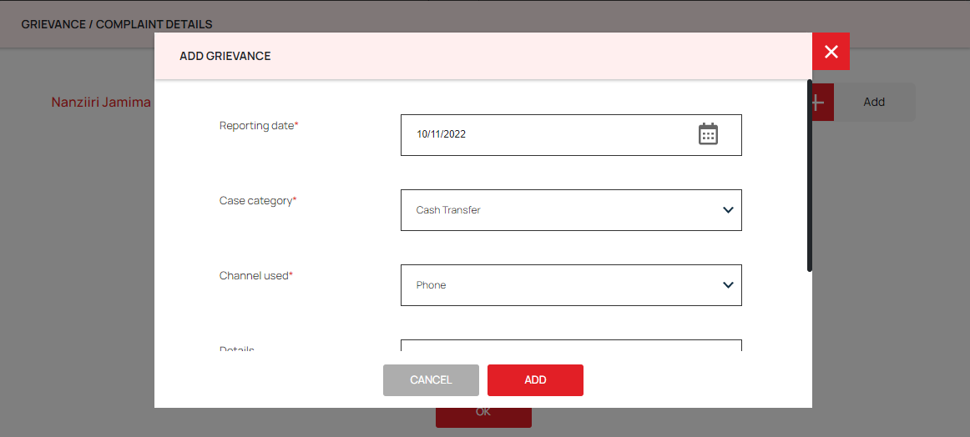Details

END OF THE DOCUMENT